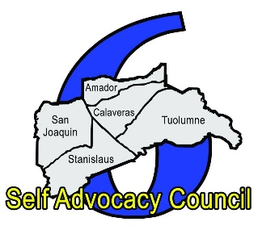

Self Advocacy Council 6
Independent Contractor Application

NAME:

Address:

Number:
Email:

Submit your resume & 2 references
□ Resume
□ 2 References

Tell us 3 things that excite you about this independent contractor opportunity:

Mail by June 19, 2026 to:
Self Advocacy Council 6- Kenneth Huntley-Chair
702 North Aurora Street
Stockton, CA 95202

